Ticketing System Set-up and Utilisation

The goal of this project is to allow me to gain confidence and familiarity with ticketing systems, which will help me to transfer the skills that I learn here into a real world IT environment.

1) I created a Linode account and set up my payment details
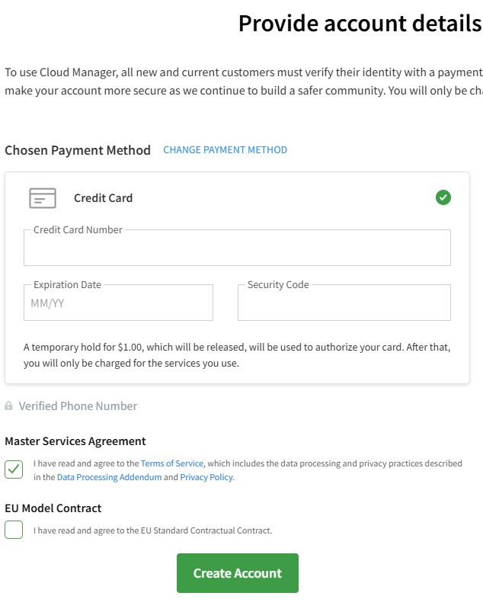

2) I then navigated to my Cloud Manager and selected “Create”
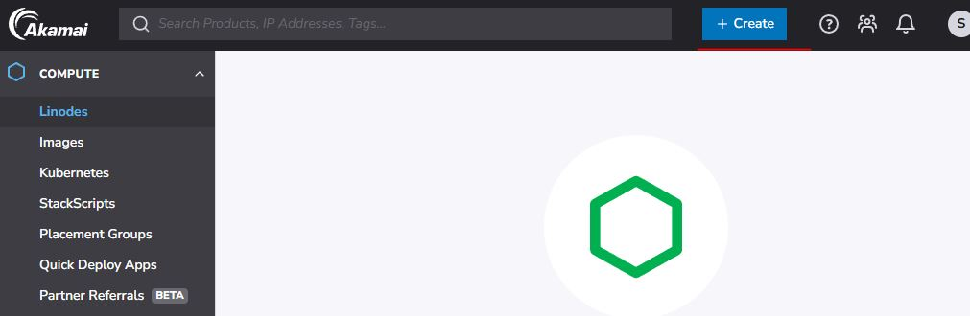

3) I then selected “Linode”

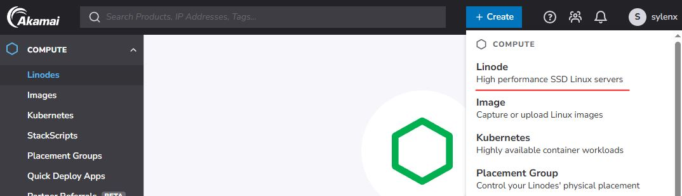
4) I then navigate to “Quick Deploy Apps” and search for “Peppermint”

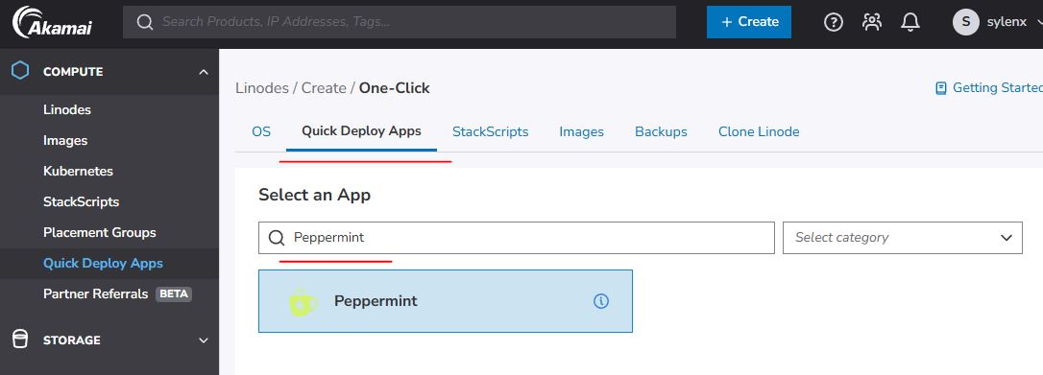
5) I can now begin to set up Peppermint (API Token, Sub-Domain, Domain, Admin email address, region etc)
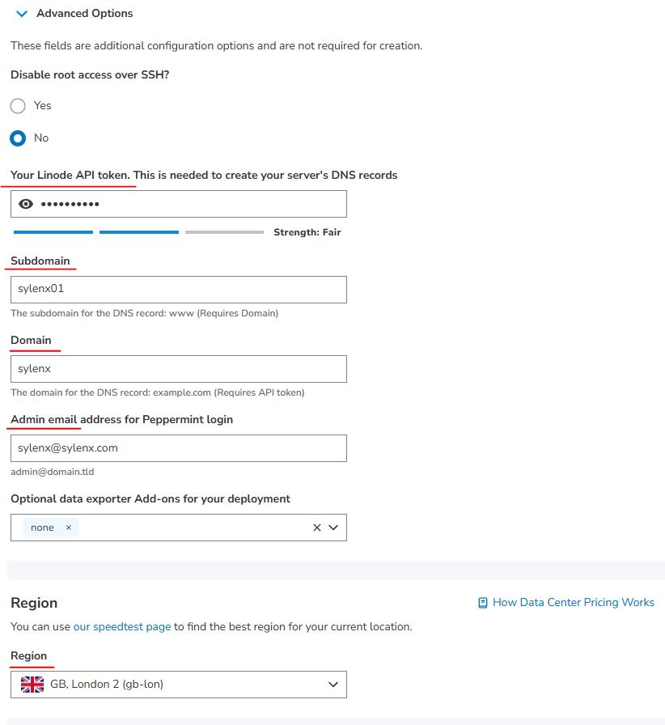

6) The first part of the set-up has now been complete

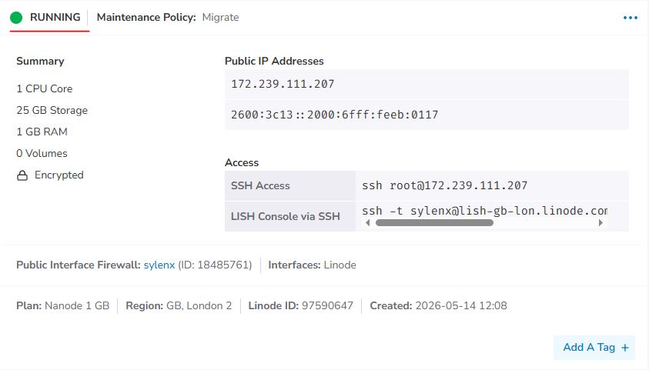

7) I can now begin the second part of the set-up by launching the LISH Console

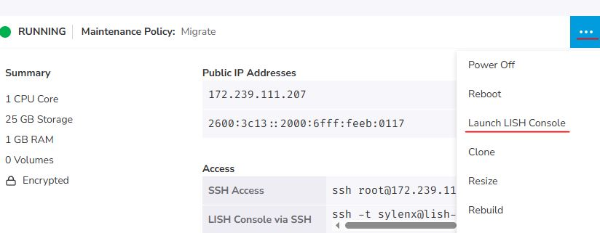
8) I begin by logging into the root account
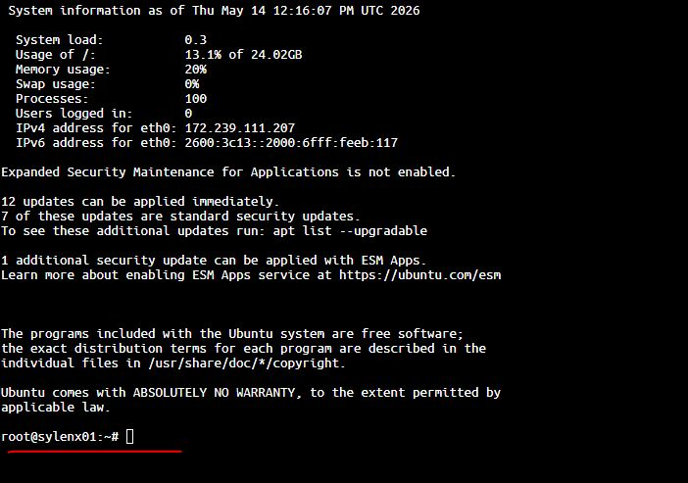

9) I check to see if Docker is present using “docker ps”

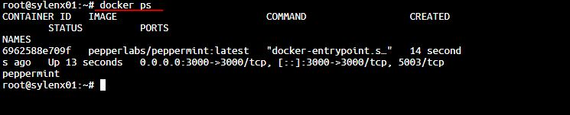
10) I then make a directory for peppermint

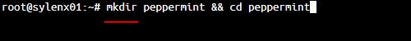

11) Then I create a yml file with nano

12) I then go to the Reverse DNS in the Network tab
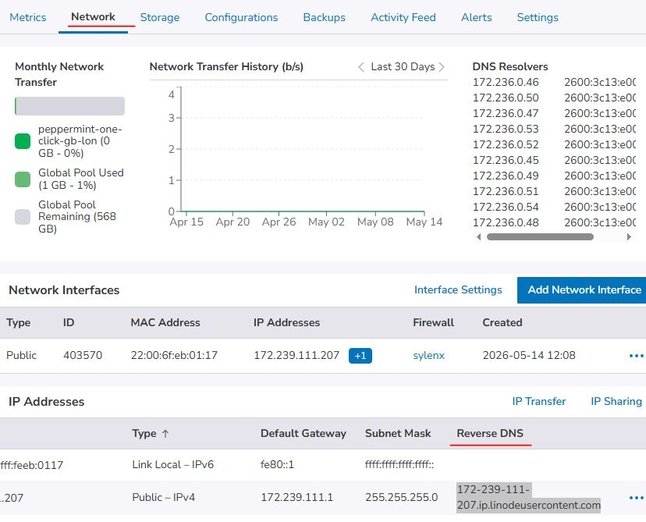

13) I then copy the Reverse DNS and paste it into the browser with port 3000 – which navigates me to the Peppermint Login Page
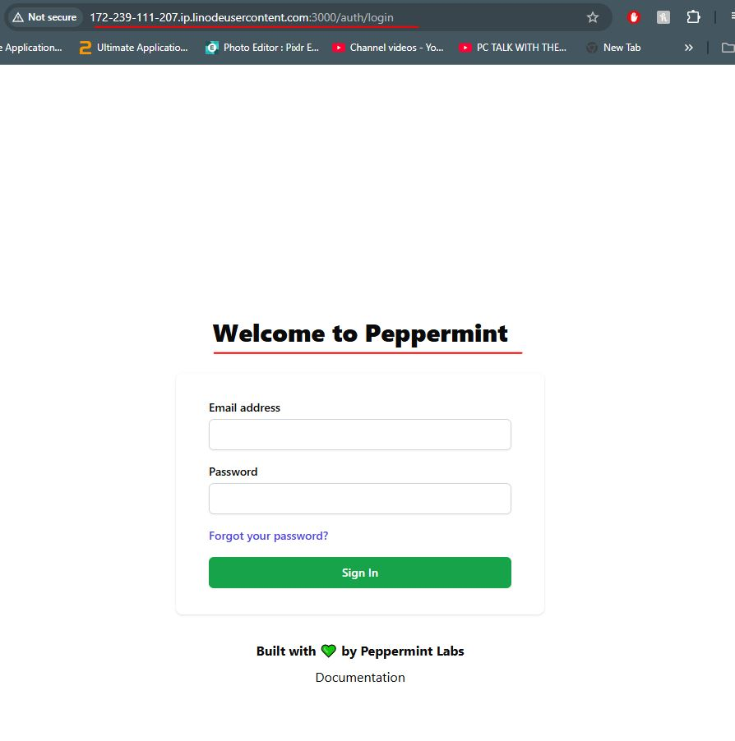

14) Once logged in, I can then begin to create, assign and complete tickets

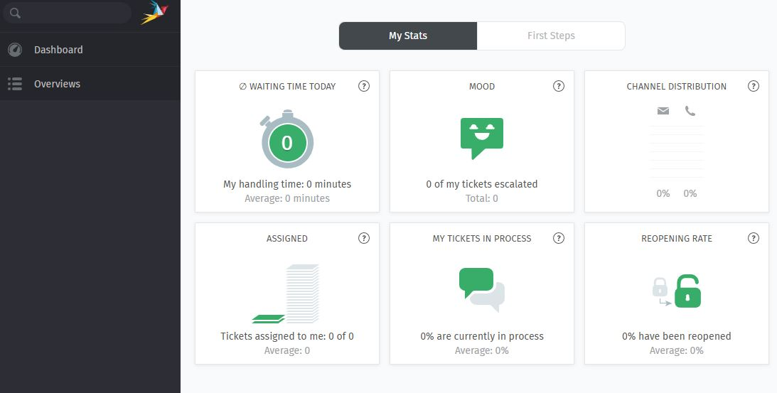
15) Example Ticket (1) – Password Reset:

- Ticket Creation:
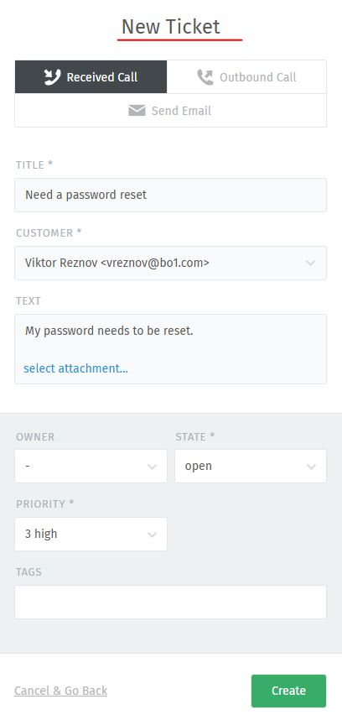

Ticket Assignment:

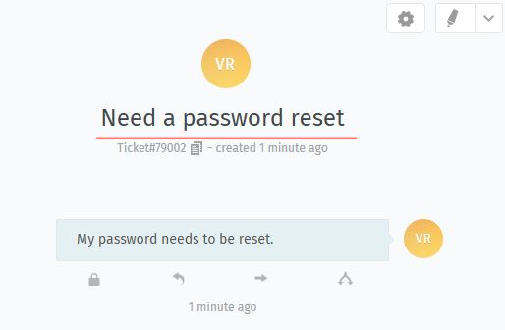

Ticket Process:
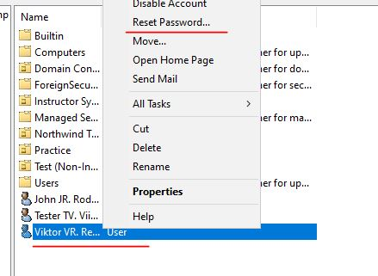

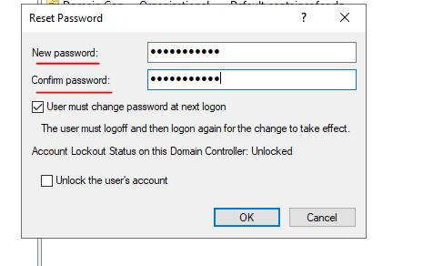

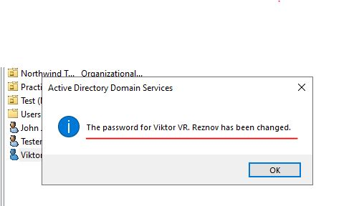

16) Example Ticket (2) – User Account Creation:

- Ticket Creation:
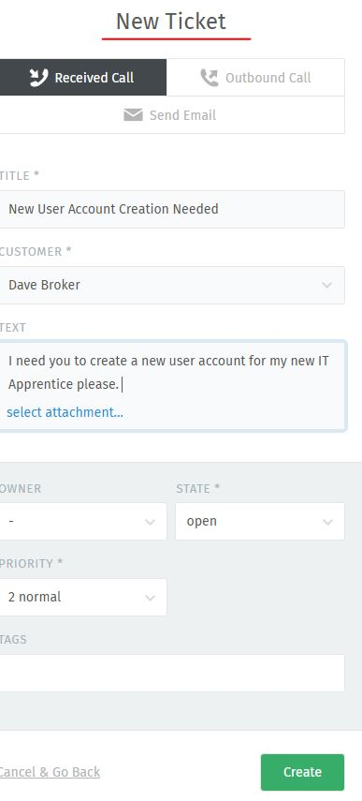

- Ticket Assignment:

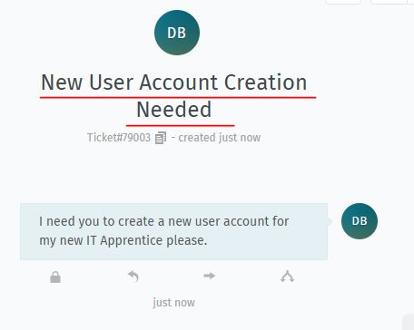

- Ticket Process:
